

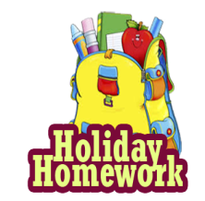

**Summer holiday homework 2025-26**

**Class-IV**

**Subject-English**

Q.1- Complete the following worksheets in your Holiday homework**(Fun with Learning)** book.

i) Worksheet 1 A funny world. II) Worksheet 2 Nouns around us.

III) Worksheet 3 Collective nouns. IV) Worksheet 4 Pronouns.

V) Worksheet 5 Adjectives. VI) Worksheet 6 Verb Train.

VII) Worksheet 18 More about adjectives. VIII) Worksheet 19 Making Questions.

IX) Worksheet 20 Types of sentences. X) Worksheet 24 Types of Adjectives.

Q.2-Write one page of cursive writing everyday.

Q.3-Learn and write following definitions-

i) Noun and its kinds ii) Common noun iii) Proper noun

iv) Collective noun v) Abstract noun

Q.4-Reading a page daily from your English book.

Q.5-Learn and write two Rhymes/Poems on a chart paper with related picture.

Q.6-Learn and write 5 new words daily along with their meanings.

**विषय:- हिन्दी**

1- आठ पंक्तियों की एक कविता लिखे और याद करें |

2- अच्छा व्यक्ति बनने के लिए हमारे अन्दर कौन-कौन से गुण होने चाहिए |

3- धरती हमें क्या-क्या देती हैं? एक सूची बनाइए |

4- भाषा किसे कहते हैं ? भारत की राजभाषा बताइए |

5- हिन्दी वर्णमाला के स्वर और व्यंजनों को अलग-अलग लिखिए |

6- नीचे दी गयी वर्कशीट को अपनी हॉलिडे होमवर्क **(Fun with Learning)** बुक में कीजिए-

1. वर्कशीट -1 खेल – खेल में
2. वर्कशीट - 2,3,4,5- शब्द ज्ञान
3. वर्कशीट – 15,17 – लिपि चिहन

7- प्रतिदिन 2 पर्यायवाची शब्द व 5 विलोम शब्द याद करके लिखें |

8- प्रतिदिन अपनी पाठ्य पुस्तक का एक पेज पढ़कर सुलेख करें |

9- अपने विद्यालय पर 15 पंक्तियाँ लिखें |

10- इक्कीस(21) से पचास (50) तक हिन्दी गिनती लिखिए |

**Subject- Maths**

Q-1.Complete the following worksheets in your Holiday homework **(Fun with Learning)**book.

i) Work sheet 1to 8 Mixed Bag

* Place value
* Comparing and ordering
* Skip counting
* Expanded form
* Even and odd numbers
* Roman Numbers

ii) Work sheet- 9 to 13

* Addition & Subtraction

iii) Worksheet -14 & 15

* Magic Square and Rounding Numbers.

Q 2-Learn and write the tables from 2 to 20.

Q.3- DoRevision of chapter-1 and chapter-2.

Q.4- Write the Roman numerals from I to L (1 to 50).

Q 5-Write the number names from 100 to 150.

Q.6-Prepare a Indian place value chart.(On chart paper)

Q.7- Reverse counting 500 to 1.

Q.8-Find the place value of each digit of the following-

i) 98756 ii) 68592

Q-9. Draw the fraction chart.

**Subject-Science**

Q.1- Complete the following worksheets in your Holiday homework**(Fun with Learning)** book.

I) Worksheet 1 Becoming a scientist II) Worksheet 2 Food

III) Worksheet 3 Digestion of food IV) Worksheet 4 Take care of your teeth

V) Worksheet 5 Insects VI) Worksheet 6 Plants our green friends

VII) Worksheet 7 Exercise for Health VIII) Worksheet 9 Air

IX) Worksheet 10 More about Air

Q.2- Book Reading: chapter 3 and chapter 4.

Q.3- Draw a balance diet diagram on A4 size paper.

Q.4-Draw safety signs in your notebook.

Q5.-Write 5 things that you must keep in your mind to keep the environment clean.

Q.6-Write about Air pollution and water pollution.

**Subject- Social science**

Q.1- Complete the following worksheets in your Holiday homework**(Fun with Learning)** book.

I) Worksheet 4 Two great kings II) Worksheet 5 National Holidays

III) Worksheet 6 Our needs and wants IV) Worksheet 7 Safety rules

V) Worksheet 9 Festivals VI) Worksheet 11 Food

VII)Worksheet 12 Shelter VIII) Worksheet 13 Water

Q.2-Collect pictures of different types of plants and animals and paste on A4 size paper.

Q.3-Collect the pictures of any five historical monuments and paste them in your notebook.

Q.4-Answer in one word-

i) Highest peak in the world ii) Highest peak in India

iii) Highest peak of Himalayas iv) First people to climb mount Everest

v) First woman to climb mount Everest

Q-5. Prepare a list of 5 national parks of India.

**Subject- Computer**

Q.1-Complete the following worksheets in your Holiday homework**(Fun with Learning)**book.

1. Worksheet 1- Computer
2. Worksheet 2- Computer Room Manners

Q.2-What is the difference between hardware and software?

Q.3-Prepare a project on the following topics-

i) Computer room manners ii) Storage devices

iii) Picture of keyboard and mouse

Q.4-Book reading from page no.38 to 60.

**Subject- G.K.**

Q.1- Write the name of 10 Countries and their capitals.

Q.2-Paste pictures of any 5 famous monuments from around the world and write 5 lines about each.

Q.3-Write the name of 10 freedom fighters of India.

Q 4-Draw and colour the picture of any 3 national symbols.

Q.5-List 5 ways to save water at home.

Q.6-Write the name of 8 planets in our solar system in order of their distance from the sun.

Q.7-Give the answer of the following-

i)Who wrote national anthem?

ii)Who wrote national song?

iii)Who is the present President of India?

iv)Who was the first woman President of India?

**Subject – Drawing**

Q- 1 "Practice writing A to Z calligraphy letters in your notebook with the help of given examples.

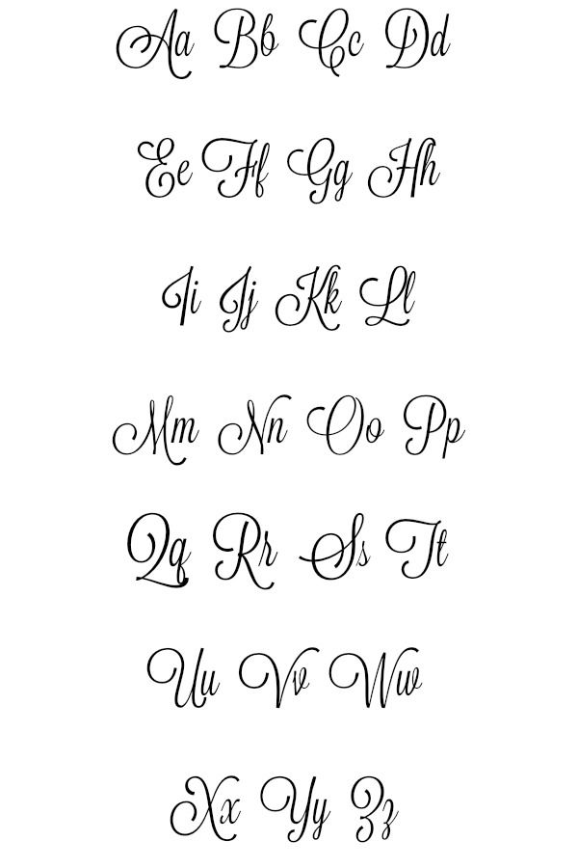

**Creativity corner :-**

**Prepare a Father’s day card, give it to your father and take a short video or pictures.**

1- Father' day Celebration on 15 June 2025

**Prepare a short video or take pictures related to any one activity**

1- Environmental day Celebration on 5 June 2025

2- Use any recyclable material like - plastic , bottle, cardboard boxes, old C.D and make any craft material

3- Reuse rain water

4- Plant any indoor or outdoor plant in your house

5- Any ecofriendly activity to save mother earth.

6- Implant Any seed in soil and observe its growth.

**Perform any one activity and prepare a short video or take some pictures.**

1- International Yoga dayCelebration on21 June 2025

2- Surya namaskar

3- Tadasana (Mountain Pose)

4- Vrksasana (Tree pose)

5- Bhujangasana (Cobra Pose)

6- Paschimottanasana (seated Forward bend)

**Note – (i) Revise the syllabus covered so far in every subject.**

**(ii) Use your subject notebook to solve question.**

**iii) 5 marks will be awarded in each subject in Periodic test-II for completing the holiday homework.**